**Chiu Pit Ho 17212049**

**ISEM 3006 Data Management in Business**

**Semester 1 2020/21**

**Exercise 1**

**On Relational Algebra**

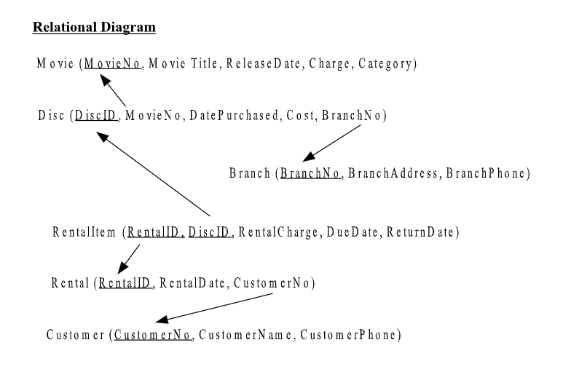

1. List the disc ID and movie number for those discs with cost higher than 120 and are held by the branch with branch number equal to 88.

Movie EQUIJOIN Disc ON (Movie.MovieNo = Disc.MovieNo) > Temp

RESTRICT (Cost >= 120 AND BranchNo = 88) ON Temp > Temp

PROJECT DiscID, MovieNo FROM Temp

1. List the movie number and the movie title of the discs that are held by the branch with address ’20 Renfrew Road’.

Movie EQUIJOIN Disc ON (Movie.MovieNo = Disc.MovieNo) > Temp

Temp EQUIJOIN Branch ON (Temp.BranchNo = Branch.BranchNo) > Temp

RESTRICT (BranchAdress = ’20 Renfrew Road’) ON Temp > Temp

PROJECT Movie Title, Movie.MovieNo FROM Temp

1. List the branch number and branch address of the branches that do not hold any disc.

PROJECT BranchNo FROM Disc > Temp

Branch LEFT OUTER JOIN Temp ON (Temp.BranchNo = Branch.BranchNo) > Temp

RESTRICT (Temp.BranchNo IS NULL) ON Temp > Temp

PROJECT Branch.BranchNo, BranchAddress FROM Temp

1. List the branch number and the address of the branches which hold at least one disc.

PROJECT BranchNo FROM Disc > Temp

Branch EQUIJOIN Temp ON (Temp.BranchNo = Branch.BranchNo) > Temp

PROJECT Branch.BranchNo, BranchAddress FROM Temp

1. List the branch number of the branches which hold discs of 'Drama' movie BUT NOT discs of 'Action' movie.

RESTRICT (Category = ’Drama’) ON Movie > TempD

TempD EQUIJOIN Disc ON (TempD.MovieNo= Disc.MovieNo) > TempD

RESTRICT (Category = ’Action’) ON Movie > TempA

TempA EQUIJOIN Disc ON (TempA.MovieNo= Disc.MovieNo) > TempA

TempD EXCEPT TempA > Temp

PROJECT BranchNo FROM Temp

1. Similar to (5), list the branch number, address and phone number of the branches which hold discs of 'Drama' movie BUT NOT discs of 'Action' movie.

RESTRICT (Category = ’Drama’) ON Movie > TempD

TempD EQUIJOIN Disc ON TempD.MovieNo= Disc.MovieNo > TempD

RESTRICT (Category = ’Action’) ON Movie > TempA

TempA EQUIJOIN Disc ON (TempA.MovieNo= Disc.MovieNo) > TempA

TempD EXCEPT TempA > Temp

PROJECT BranchNo FROM Temp> Temp

Temp EQUIJOIN Branch ON (Temp.BranchNo = Branch.BranchNo) > Temp

PROJECT Branch.BranchNo,BranchAddress,BranchPhone FROM Temp

1. List the customer number of the customers who have rented ALL movies. (Note: All Movies, not all Discs. One movie may have multiple discs.)

Customer EQUIJOIN Rental ON (Customer.CustomerNo = Rental.CustomerNo) > Temp

Temp EQUIJOIN RentalItem 0N (Temp.RentalID = RentalItem.RentalID) > Temp

Temp EQUIJOIN Disc 0N (Temp.DiscID = Disc.DiscID) > Temp

PROJECT MovieNo,CustomerName FROM Temp > Temp

PROJECT MovieNo FROM Movie > TempD

Temp DIVIDED BY TempD

1. List the customer number of the customers who have rented ALL 'Action' movies.

Customer EQUIJOIN Rental ON (Customer.CustomerNo = Rental.CustomerNo) > Temp

Temp EQUIJOIN RentalItem 0N (Temp.RentalID = RentalItem.RentalID) > Temp

Temp EQUIJOIN Disc 0N (Temp.DiscID = Disc.DiscID) > Temp

PROJECT MovieNo,CustomerName FROM Temp > Temp

RESTRICT (Category = ’Action’) ON Movie > TempD

PROJECT MovieNo FROM TempD > TempD

Temp DIVIDED BY TempD